**ICS 4UC Tower Defence Version 1.0**

Work towards this for your desired endpoint. This took me about 2 hours to set up. You should at least be able to create the subclasses and call their constructors in the world subclass to test them. You may be able to create the additional functionality using the documentation and the example of what we have already done.

WHAT'S HIGHLIGHTED IN YELLOW IS COMPLETED IN MY CODE

**Iteration 1**

**The program must be on time (3 marks)**

Three Actor subclasses

1. Tower class must:
   1. towers can be placed in the world
   2. towers fire bullets with a cooldown (do not spam bullet firing)
   3. Towers use some kind of aiming logic to fire at enemies

Towers may:

* 1. towers can be placed in the world using mouse or key interactions
  2. tower subclasses allow for varied attacks (slow, area of effect)
  3. towers have a firing animation
  4. towers have sounds
  5. towers can be upgraded
  6. Have a cost associated with building and upgrading

1. Bullet class must
   1. bullets are removed when they travel their range
   2. bullets are removed when they strike an enemy

Bullets may

* 1. bullets have sounds when they strike an enemy
  2. different bullet subclasses have significantly different behaviours

1. Enemy class must
   1. enemy class is a sub-class of my asbtract AbstEnemy class
   2. enemies are spawned into the World subclass
   3. enemies travel along a predetermined path of waypoints
   4. enemies take damage from bullets
   5. enemies are removed when they have zero health

Enemies may

* 1. show an explosion when hit by a bullet (could be handled by bullet)
  2. have walking animation
  3. have subclasses which have significantly different behaviours
  4. remove player health when end reached
  5. drop loot
  6. Have healthbars

You product may look similar to this.

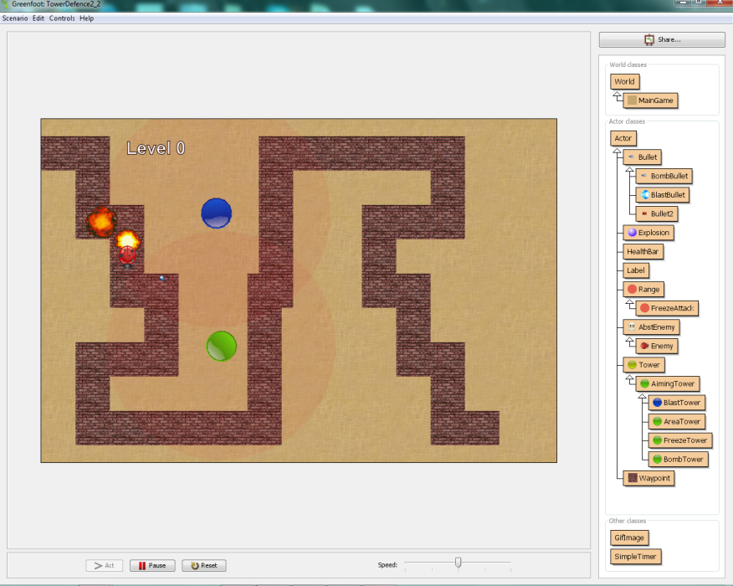

Iteration 2

Critical Requirements (Your solution must have all these things)

Optional requirements

* Use of animated gifs
* Explosion sounds
* Javadocs documentation completed
* Magical mystery options of impressive quality